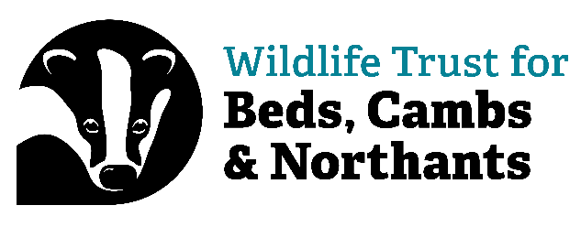

Volunteer Role: Voluntary Reserves Officer (VRO) - North Cambridgeshire
Expression of Interest

Thank you for your interest in the role of Voluntary Reserves Officer. It would be helpful if you could tell us a bit about yourself and why this role appeals to you. Please complete the following. You must be 18 or over to apply.

Section 1: Personal Details

Name:__________________________________________________________________________________

Office use only
Support Officer: Group/Team:………………………………………………………………..

Home address including postcode:________________________________________________________________________________________________________________________________________________________________________________________________________________________________________________________________________________________________________________________________

Phone No. (Specify home/work/mobile):_________________________________________________________________

Email address: __________________________________________________________________________________

Do you hold a valid driving licence? Yes/No (delete as applicable).

Section 2: On a separate page below, please tell us a bit about yourself. This might include the following:

- Why you would like to be a Voluntary Reserves Officer; what you hope to gain from the experience including if you have an Interest in pursuing a career in wildlife conservation.

- What motivates you, and if you like working hard outdoors in all weather (with examples of anything you have done)

- Any experience you have of similar practical work

- Any experience you have of using hand tools, power tools and machinery

- Any experience you have of working with a wide range of people including any leading of groups

- Any relevant education and / or experience / or interest in the area of wildlife conservation / natural history

- If you are computer literate

Section 3: Important information:

Equality, Diversity and Inclusion
We’re wild about inclusion and want our staff and volunteers to be as diverse as wildlife. As an inclusive organisation we want our staff and volunteers to better reflect the communities in which we live and work. We actively encourage applications from people of all backgrounds, identities and cultures. We believe that diverse staff and volunteers will help us create our vision of ‘people close to nature, with land and seas rich in wildlife.’ We will not accept discrimination by staff or volunteers. A copy of the Equal Opportunities Policy is available upon request.

Recruitment Data Privacy Statement
In order to operate the Wildlife Trust for Bedfordshire, Cambridgeshire, and Northamptonshire’s (“The Trust”) volunteer recruitment system, we will collect and store personal information you submit via this form and any CV that you may provide. Some of the information on this form is mandatory in order for the Trust to consider your application or to meet our statutory monitoring and reporting responsibilities. However, where indicated, some of the information is optional and you can choose not to provide it.

By completing this form you give your consent for us to send you information regarding volunteering opportunities.

Would you be happy to hear from us about projects, events, and fundraising news by:
Post Yes / No (please delete as appropriate)
Telephone Yes / No (please delete as appropriate)
E-mail Yes / No (please delete as appropriate)

We will send you information as per your instructions above. If at any time you would like to change how we keep in touch, simply tell us and we’ll act on it straight away.

I understand my details will be held on the Wildlife Trust BCN database.. I certify that the information I have given is true and complete. I understand that any data I gather as part of volunteering will be used for the work of the Wildlife Trust BCN

Your signature Date_________________________

Please return to volunterring@wildlifebcn.org

Thank you. We will be in touch.

