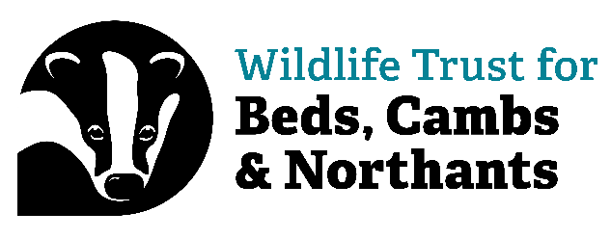

Confidentiality Agreement for Volunteers

Whilst volunteering for The Wildlife Trust BCN volunteers may have access to a variety of information concerning Trust business, that of its subsidiary companies, corporate and private members and sponsors/donors. Some of this information will be confidential.

Volunteers must respect confidentiality and not disclose any information relating to The Trust and its associates, or act as a spokesperson on behalf of the organisation, unless authorised to do so.

Deliberate or negligent disclosure of information may lead to The Trust terminating your volunteering arrangements.

If you do receive unusual requests for information on the organisation, you must seek clarification from your named support officer / manager before passing on the information.

It is also important that you do not discuss confidential information with anybody outside RSWT during or after any period of volunteering.

I understand the above and agree to follow these rules.

Name__________________________________________________________________

Date___________________________________________________________________

Signed__________________________________________________________________

