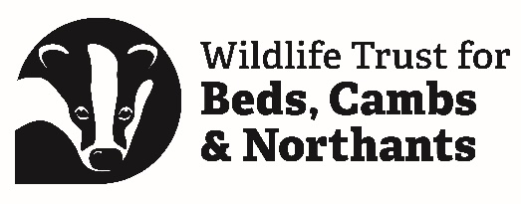

Volunteer Role: Young People’s Forum Member

Support Person | Laura Allen and Alison Chaves  Communities and Education Officers
Role Purpose | To work as part of a small team of around 10 to 15 other young people to support the Trust to work better for young people.
Specific Tasks | Volunteers may be involved in:  - Advising the Trust on how to meet the needs of young people interested in conservation and environmental issues.  - Representing the Trust to other young people by, for example, promoting events and giving presentations.  - Organising events for young people  - Creating content for social media and the Trust’s website  - Forum and Trust related Projects  - Fundraising
Skills and Qualities Needed | We are looking for members who have a passion for local wildlife and global environmental issues like the climate chaos and the loss of biodiversity.  Every member needs to be:  - Aged between 13 and 24  - Passionate about conservation  - Living, working, or studying in Bedfordshire, Cambridgeshire or Northamptonshire  - A member of the Trust (or willing to become a member - we offer free membership for Forum members)  - Confident representing the views of other people to staff, trustees, and peers  Diversity and inclusion are extremely important to us and we are committed to creating an environment where young people from all backgrounds feel welcome, listened to, and valued. We encourage applications from young people currently underrepresented in the environmental movement, including young people from Black, Asian and Minority Ethnic (BAME) backgrounds, young people with disabilities, young people from working class backgrounds and LGBT+ young people.
Commitment | - Be able to attend the four weekend face-to-face meetings  - Be able to attend as many evening online meetings as possible (these may happen 8 or more times a year)  - Create content such as articles, blogs or videos on projects or issues the Trust is focusing on  - Spend some time outside of the meetings helping to organise events, work on projects and read relevant emails or communications  - Be able to talk to other young people to share information and listen to ideas and concerns  - Represent other young people  - Be committed to and uphold the values and visions of the Trust  - Be a member of the Forum for at least one year
Support and Training | The Trust will:  - Ensure that Forum meetings are engaging, with opportunities to learn.  - Provide a variety of free training opportunities that will help you fulfil the role of Forum member.  - Have a member of staff to support you in the role.  - Offer social events (some online) for Forum members.  - Help with transportation to and from Forum events, if needed.  - Provide refreshments at events.
Expectations of WTBCN Volunteers | The Trust expects volunteers to:  - Be passionate about wildlife, and share the values of the Wildlife Trust  - Be willing to follow the Trust’s policies and procedures  - Keep to any confidentiality asked  - Stick to the agreed ground rules at meetings  - Respond promptly to communications  - Be willing to undergo a DBS (police) check if over 18  - Attend all meetings where possible, and let us know if they can’t come  - Treat other people’s views with respect  - Be prepared to speak their mind and to ask if they don’t understand  - Take an active part in decision-making  - Be keen to learn new things  - Carry out any tasks they volunteer for  - Read any relevant paperwork before each meeting  - Be able to work well online and in person  - Attend training as required
Location of volunteering | Our four face-to-face meetings will be held at different locations around our three counties, most likely at one of our centres or offices. Attendance at these is essential.  There will also be shorter meetings which will take place online at more regular intervals (roughly eight times a year but may be more frequent).

