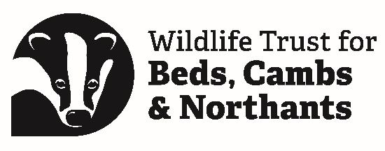

Application Form for Young People’s Forum Volunteer
Name
Surname
Email address
(If under 18, this needs to initially be for a parent/guardian)

If under 18, please provide the full name of a parent/guardian.

Please confirm that you:
Are aged 13-24
Are a member of the Wildlife Trust BCN, or are willing to join
Live, work or study in Bedfordshire, Cambridgeshire, or Northamptonshire
Can commit to at least four in-person meetings per year (held on Saturdays).

Additional online sessions will be held on Wednesdays 6pm-7:30pm.

Application
Please tell us why you would like to join our Young People’s Forum.
You might do this in a short blog (max 500 words), a video (max 3 minutes) or come up with another creative idea. If you find answering online forms difficult and would prefer to talk through your application with us, please let us know by emailing youngpeoplesforum@wildlifebcn.org.
Please include examples to show:
- that you are passionate about environmental issues and local wildlife
- how you would represent the diverse communities of young people that live in our area
- that you are confident (for this role, you will need to be able to do things like talk to people you don’t know well, speak your mind, and ask if you do not understand something)
Please do not include the following:
- Uniforms with logos (including schools, colleges, or work)
- House numbers or street names
- Photos/videos of anyone other than yourself (e.g., please do not include photos with peers or friends as they may not have given permission for use within this application)
Next steps
Please send a completed application form to youngpeoplesforum@wildlifebcn.org.
Once we have received your application, a member of Wildlife Trust staff will be in touch with an invite to an online Teams call. This will provide the opportunity to meet you, provide further information about the Forum and answer any questions you may have.
Following this call, Wildlife Trust staff will speak to the Forum (at the next meeting) to let them know about your application. A member of staff will then let you know whether your application had been successful.
Data protection
We will use the data supplied above to maintain our records for communication & safeguarding purposes
Personal details will only be used by the Wildlife Trust BCN and will not be passed on to any third party.
For more details on how we use your data see www.wildlifebcn.org/privacy.

