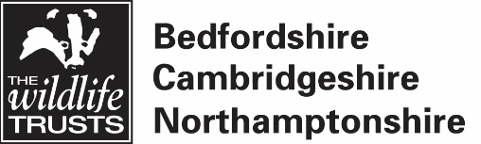

Application process for Young People’s Forum Volunteer

- Name:

- Email address (if under 18, this needs to initially be for a parent/guardian):

- Please confirm that you
☐ are aged 11-24
☐ are a member of the Wildlife Trust BCN, or are willing to join
☐ live, work or study in Bedfordshire, Cambridgeshire or Northamptonshire
☐ can commit to at least four in-person meetings per year, with additional online sessions

- We want you to tell us why we need you on our Young People’s Forum. You might do this in a short blog (max 500 words), a video (max 3 minutes) or come up with another creative idea. You will need to show us:
- that you are passionate about environmental issues and local wildlife
- how you would represent the diverse communities of young people that live in our area
- that you are confident (for this role, you will need to be able to do things like talk to people you don’t know well, speak your mind, and ask if you do not understand something)

Data protection

We will use the data supplied above to maintain our records for communication & safeguarding purposes
Personal details will only be used by the Wildlife Trust BCN and will not be passed on to any third party.

For more details on how we use your data see www.wildlifebcn.org/privacy.

