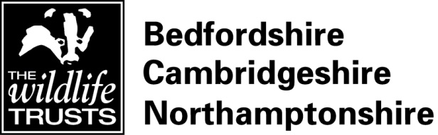
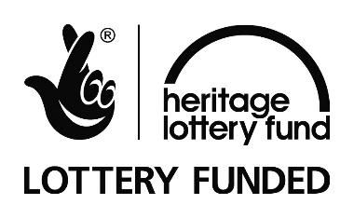

Volunteer Role Description

Role Type: Volunteer Weekend Ranger– Nene Wetlands (Rushden Lakes)

Where: The Wildlife Trust BCN Nene Wetlands Visitor Centre, Rushden Lakes Retail Park.

When: All year round, minimum 1 day per month

Commitment: Flexible during Visitor Centre core opening hours 10am to 4pm, and additional hours as required. This is a long term volunteering commitment and the ability to commit to regular days and times would be ideal.

Duration: Ongoing

Overview:

We are currently looking for volunteers who would like to join our team at Rushden Lakes, in the role of Volunteer Weekend Ranger.

The Nene Wetlands is a flagship reserve for the Wildlife Trust BCN and, being adjacent to the Rushden Lakes Retail Park, has a far greater number of visitors than many of our other reserves, particularly at weekends. This creates lots of opportunities for us to engage new people with wildlife and the vital work of the Wildlife Trust BCN. However, it also places additional pressures on the reserve and its inhabitants.

We are looking for volunteers to help us to increase our presence on the ground, talking to visitors about the wildlife they may have or might see, explaining how to enjoy the reserve responsibly and highlighting the work that the Wildlife Trust BCN is doing to help local wildlife.

The role of Volunteer Weekend Ranger will be vital to ensuring visitors to the reserve, and in particular, Skew Bridge Lake, have an enjoyable and informative visit and are supportive of the work of the Wildlife Trust. The role can be flexible to your skills and interests, and will entail some or all of the following:

- Talking to visitors on the reserve, pointing out interesting wildlife sightings and offering advice on the best spots to see wildlife.
- Answering visitor questions and queries about the site
- Providing information to visitors about events & activities, volunteering opportunities and Wildlife Trust membership
- Helping to ensure people use the reserve responsibly (pointing out rules and restrictions such as where they can cycle, fish and let dogs off of leads)
- Helping to make sure the reserve is safe and tidy by picking up litter, checking play equipment etc. (all necessary training and PPE provided)
- Supporting the Visitor Centre duty manager by responding to issues on the reserve, such as reports of injured wildlife.

Qualities / Experience / Skills sought:

If you have an interest and enthusiasm for wildlife and enjoy working with people, then this may be the volunteer opportunity for you. We’re looking for people who:
- have an interest in wildlife and the work of the Wildlife Trust
- have a cheerful, friendly and approachable manner and be confident talking to the public
- are willing to act as the public face of the Wildlife Trust BCN and present a positive image of our organisation
- enjoy working as part of a team and under your own initiative
- are conscientious in their approach to undertaking tasks
- have the ability of keeping calm under pressure

Benefits to you:

As a Volunteer Weekend Ranger you will have the opportunity to be actively involved in one of the Trust’s flagship sites, and actively contribute to the experience that visitors have while they are here.

In-house training in aspects of wildlife and community engagement work is provided by Trust staff, aimed at improving volunteers’ skills and knowledge. There will also be the opportunity to attend in-house training workshops, and externally certificated courses in first aid and community engagement skills.

Why we want you:

Do you love wildlife in your local area? Do you enjoy interacting with and helping other people? If so, we’d like to hear from you!

The Wildlife Trust for Bedfordshire, Cambridgeshire and Northamptonshire has embarked on an exciting project as part of the Rushden Lakes Retail Park. We are managing the Nene Wetlands, a one square mile (270 hectare) nature reserve, made up of stunning lakes and meadows, and operating our very first visitor centre. The Nene Wetlands joins together several smaller wildlife refuges to create a huge space for wildlife and nature and for people to use and enjoy. The visitor centre acts as a gateway to the Nene Wetlands and the wider Nene Valley, and is crucial in raising the profile of the Wildlife Trust in the area.

Notes: The Wildlife Trust is a wildlife conservation charity that works for a better future for all kinds of wildlife across Bedfordshire, Cambridgeshire and Northamptonshire. Our mission is to protect and improve habitats and wildlife in our local area as well as helping people to enjoy and understand their local wildlife.

For more information please contact:
Name: Viktoria Marta
Telephone: 07931325888
Email: viktoria.marta@wildlifebcn.org

The Nene Wetlands is supported by the National Lottery through the Heritage Lottery Fund.

