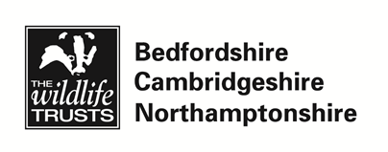

Volunteer Role: Community Fundraising volunteer

Support Person | Helen McLean
Role Purpose | The purpose of the role is to develop and produce a set of Community Fundraising guidelines in order to help people fundraise for the Wildlife Trust
Specific Tasks | Researching and creating resources, e.g. posters, downloadable PDFs, to distribute to community fundraisers and corporate supporter employees  Identifying opportunities to promote community fundraising and recruit participants  Recording requests for community fundraising resources and events held on the Trust’s CRM database, for which training will be provided
Skills and Qualities Needed | Volunteers will come from a wide range of backgrounds and will have many different qualities and skills. Essential skills and qualities for this role are:  - Good research skills, and a love of using the internet to fact-find  - Good administration and organisational skills, including computer literacy  - Creativity and the ability to condense large amounts of information into succinct guidelines  - Good team worker  - Cheerful, friendly and approachable manner
Commitment | We are looking for someone who can commit one day or two half days a week for a minimum of three months.
Support and Training | The volunteer will be given regular one to one guidance and support. Relevant training that may be required will be identified and the volunteer will be offered suitable training to meet their needs.
Expectations of WTBCN Volunteers | - Willingness to abide by the Wildlife Trust BCN’s Policies and Procedures  - Willingness to use support systems  - Co-operation with administrative tasks e.g. filling in expenses forms  - Commitment to attend on-going training
Location of volunteering | Cambourne office.

Task Description Updated: 24th May 2019

