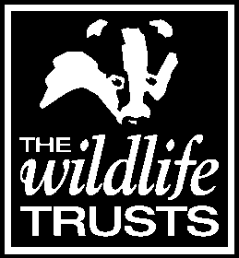
Members’ Day and AGM 2018
13th October 2018, The Manor School & Sports College, Raunds

The aim of the Members’ Day is to thank members for their support and update them on the work of the Trust.

In taking part today:

0= Not at all; 1= Not entirely; 2= Not sure; 3= Somewhat; 4= Definitely

Content

1. Did you enjoy yourself? 0 1 2 3 4

2a. Did you feel able to ask questions on things that you are particularly
interested in? 0 1 2 3 4

2b. Did you get an answer? 0 1 2 3 4

3. Were the activities and presentations appropriate and interesting? 0 1 2 3 4

4. Do you feel the aim of the day [see above] was achieved? 0 1 2 3 4

Could we improve on anything?
…………………………………………………………………………………………….
…………………………………………………………………………………………….
…………………………………………………………………………………………….
…………………………………………………………………………………………….

Organisation

5. Was the information provided before the event clear and adequate? 0 1 2 3 4

6. Was the organisation on the day of a sufficient standard? 0 1 2 3 4

Could we improve on anything?
…………………………………………………………………………………………….
…………………………………………………………………………………………….
…………………………………………………………………………………………….
…………………………………………………………………………………………….

Facilities

7. Did you feel physically comfortable and welcome? 0 1 2 3 4

8a Were the facilities at the venue satisfactory? 0 1 2 3 4

8b Was the catering satisfactory? 0 1 2 3 4

Could we improve on anything?
…………………………………………………………………………………………….
…………………………………………………………………………………………….
…………………………………………………………………………………………….
…………………………………………………………………………………………….

Name (optional):

Please complete this form and place it in the box provided before you leave.
Alternatively, post it to Anne Barker at the Trust or return it by email (pa@wildlifebcn.org)

