Hoverfly Monitoring at Old Sulehay

John Showers
October 2016

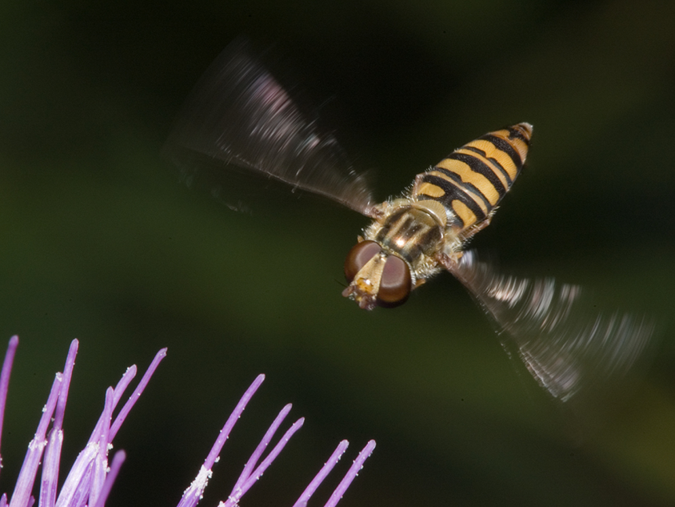

Photo by Graham Warnes

Contents

1. Summary 2
2. Introduction 3
3. Methodology 4
4. Results 4
5. Data analysis 5
6. Conclusions 12
6.1. Trends in relation to reserve management 12
6.2. Strengths/weaknesses of approach 12
6.3 Future data analysis and collection 12
7. References 13
Acknowledgements 13
Appendices 14
Appendix 1 Complete species list and indicator codes 14

Summary
Hoverfly monitoring has been conducted under the Hoverwatch monitoring scheme (Ball & Morris 2012) for seven years at Old Sulehay Forest. This report describes the methods used and the results to date. It includes the taxa recorded and their numbers; visits to flowers and analyses of the data with respect to larval ecology.
This report provides an initial expert interpretation of the data. It is suggested that a future project provides statistical analysis of the data in relation to management compartments.

Introduction
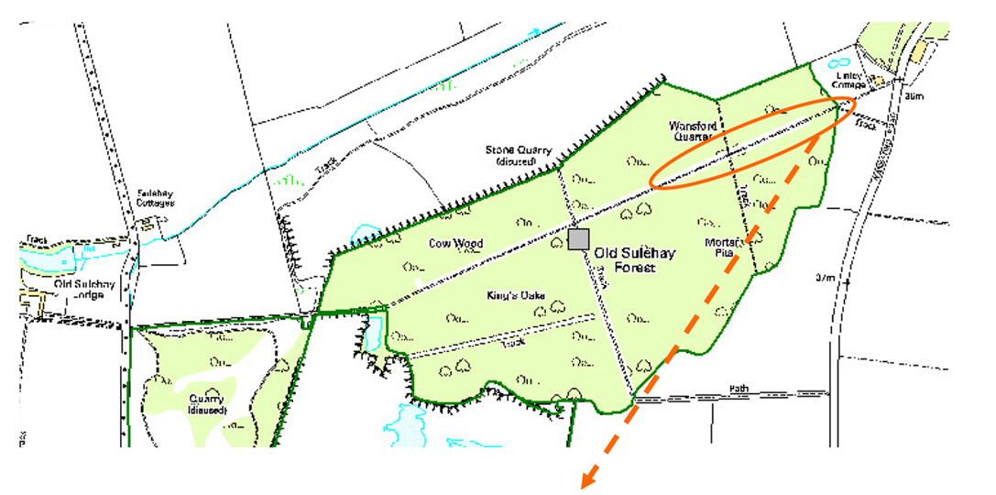
Figure 1 Map of Old Sulehay with survey area (Crown Copyright 2016)
In 2009 WT volunteers began recording hoverflies in a standardised way along the main ride at Old Sulehay (fig 1). These surveys gather information on abundance and distribution of species and what nectar sources they are visiting.
This data will be used in conjunction with nectar source monitoring to assess ride and woodland management.
Hoverflies were selected for monitoring for a number of reasons:
- Adults are almost exclusively nectar feeders;
- Adults are fairly easy to identify, at least to tribe level;
- Their larval ecology is very varied so may provide other information about the surrounding environment
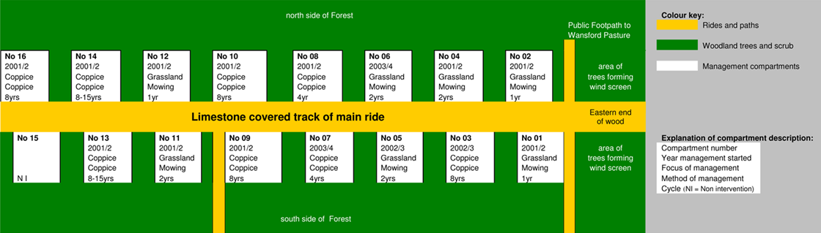
Figure 2 Example of management compartments at Old Sulehay
The main ride at Old Sulehay is managed on a cycle of coppicing, mowing, bramble slashing and non-intervention. These management compartments (fig 2) or scallops are each on a different cycle of 1, 2, 4, 8 or 15 years.

Methodology
Surveyors made 4-5 visits during the main nectar season;
- Late April – Mid-May (Hawthorn)
- Late May – Mid- June (Hogweed, Dogwood)
- Mid-June – Mid-July (Bramble, herbs)
- Late July-Early August (Herbs)
On each visit, surveyors followed this survey methodology:
- Count the numbers of each hoverfly taxa in a compartment for 3 minutes;
- Sweep the compartment for further species (2 passes) and take samples for identification;
- Note the flower species being visited;
- Fill in details on recording form;
- Return to lab to identify samples
Each hoverfly was identified to species level. Where this was not possible a higher taxon was recorded; either genus or tribe.

Results
The surveys at Old Sulehay from 2009 to date have generated the following data:
- 4977 individual records
- 91 hoverfly species (within the main project area)
- 5 species outside of the project area

After completing the formal Hoverwatch surveys, a number of informal surveys were made within Old Sulehay forest. These were located away from the main survey area to see if we were taking a representative sample of the total hoverfly fauna.

These surveys resulted in five additional species being recorded. In one case, Portevinia maculata was recorded regularly in the area of ramsons, its larval food plant. There are no ramsons in the survey area. Two species of Brachopa were recorded. These are associated with root rot and sap runs in trees. They tend to stay close to their breeding habitats and so may not come into the areas surveyed. B. insensilis was regularly recorded at the sap runs and rot-hole in the large horse chestnut at the central junction of the main rides in the forest. Calicera aurata is a rare species associated with rot-holes and was recorded once on dogwood flowers in the survey area but outside of the survey project. It was considered that the data collected did represent the overall hoverfly fauna of the wood, with these few exceptions.

Data analysis
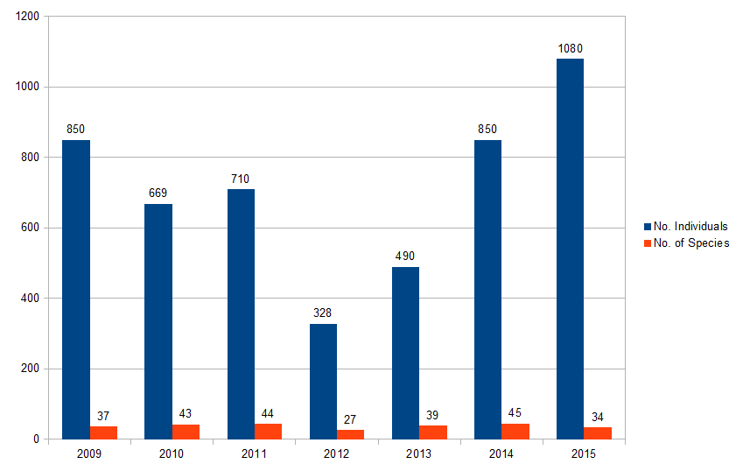
Figure 3 Hoverfly number & species recorded each year at Old Sulehay (2009-2015)
Figure 3 shows the results of each year's surveys, giving the total number of individuals recorded and the number of species. Where a higher taxon was recorded (not species), this is only shown in the table if there were no species identified that year. For example, if a record of the genus Eristalis was made, but also Eristalis pertinax was recorded then only 1 species was recorded. However if no Eristalis pertinax had been recorded, it would still count as 1 species for the genus Eristalis. This histogram does not take into account the number of visits made in the season.

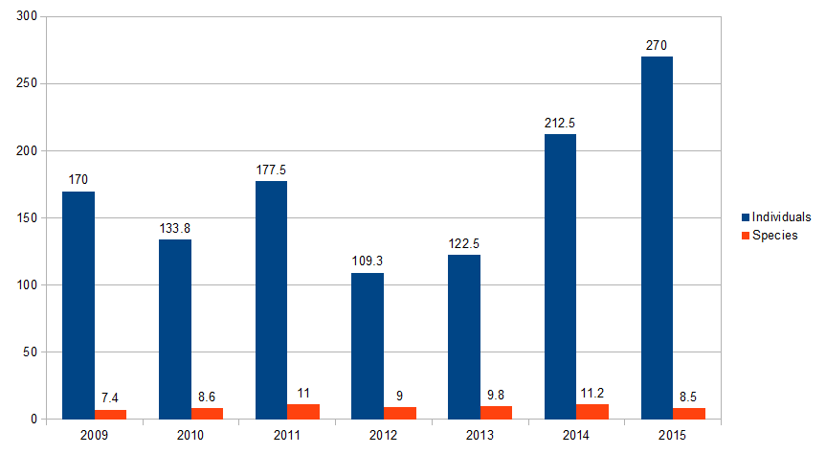
Figure 4 Hoverfly number and species per visit at Old Sulehay (2009-2015)
Figure 4 adjusts the data shown in Figure 3 to allow for the number of visits made during the season. In 2012 the early spring visit was abandoned through poor weather and the second visit was also affected but did take place. Despite the adjustment, there is still a wide variation in numbers of individuals counted. This is partly because the most abundant species Episyrphus balteatus is a partial migrant and in some years the resident population is greatly increased by immigration from the near continent. This is suspected to be the case in 2015.
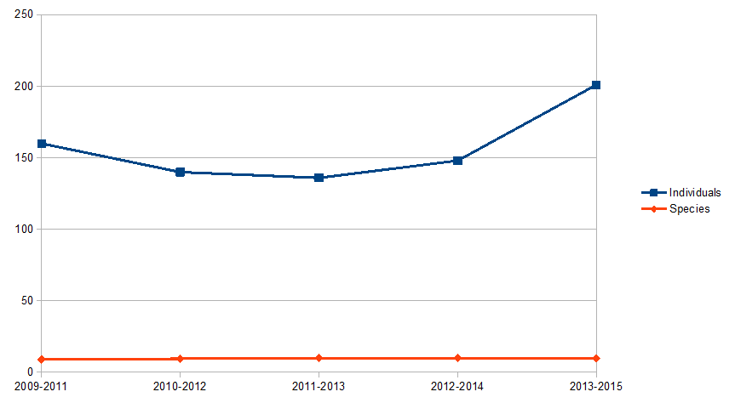
Figure 5 Hoverfly numbers and species per visit at Old Sulehay 2009-2015 (3 year running mean)
Figure 5 makes allowance for annual variations by plotting the 3-year running mean. This does show less variation, as would be expected, but the high E. balteatus count in 2015 is still causing a peak. It is noticeable, however, that the variation in numbers of species has been virtually eliminated. This could suggest that either the management of the rides and surrounding wood has had no impact on overall hoverfly diversity or that the hoverfly diversity is not sensitive to any management carried out.
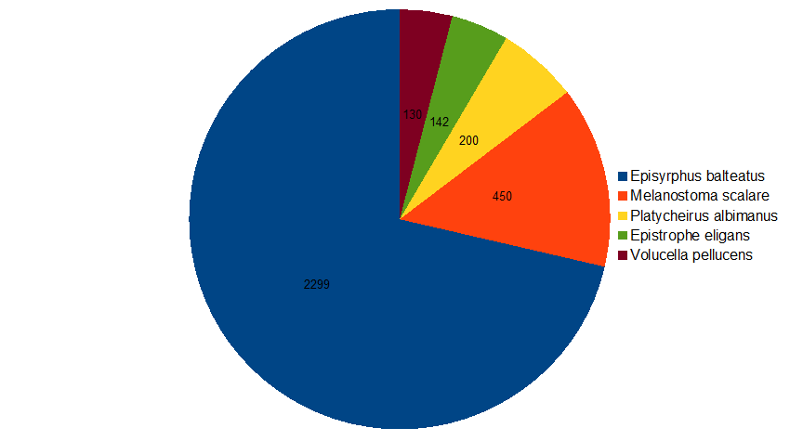
Figure 6 Most abundant Syrphidae species (species records only)

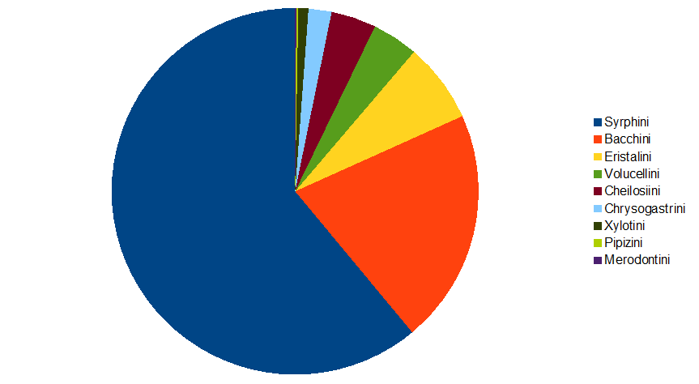
Figure 7 All data - breakdown by tribe
Figure 6 explores the relative abundance of hoverfly species but only includes data where the hoverfly was identified to species level. This shows that E. balteatus represents about 70% of all individuals recorded.
Some taxa are more difficult to identify to species; to eliminate this bias, the data has been plotted in Figure 7 at the tribe level, so that all data is included. This has the effect of bringing the Eristalini tribe into third place. Approximately 80% of all individuals recorded were in the tribes Syrphini and Bacchini. The species in these tribes have larvae which are predatory on aphids in various habitats.
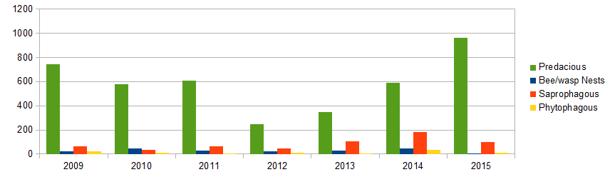
Figure 8 Larval feeding modes - individuals each year
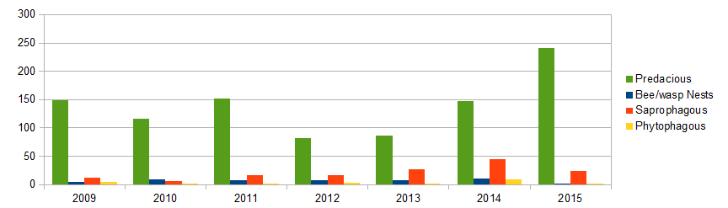
Figure 9 Larval feeding modes - individuals per visit
Figures 8 and 9 break down the overall numbers by larval feeding mode. The hoverfly family has a wide variety of larval feeding modes, more so than in most fly families. If there had been significant changes in the habitat during the survey, this might be reflected in changes to the ratios of different larval feeding modes even if overall numbers had not changed. To explore this further, the results were analysed by grouping larval feeding modes:
- Predatory. The larvae attack aphids and similar small organisms on leaves, stems or in the soil. These include all the Bacchini, Syrphini and Pipizini.
- Bee or wasp nest inqilines. These live in the nest of social bees and wasps and either scavenge on nest debris or actively predate hymenopteran larvae. These are the Volucellini, excluding Volucella inflata.
- Saprophagous. These are species where the larvae feed on bacteria in rotting vegetation, including water dwelling species and those in dung, sap runs and dead wood. They include the tribes Eristalini, Chrysogastrini, Xylotini and species Volucella inflata, Ferdinandea cuprea and Rhingia sp.
- Phytophagous. These larvae develop inside plant or fungus tissues. Includes the Cheilosiini and Merodontini.
There has not been a noticeable change in the larval feeding ratios. However, the 2015 results showed a very low Volucellini count. It is not thought that this represents a decline in bee and wasp nests but rather reflects the later flowering of bramble in this dry spring. Normally Volucellini are mainly recorded in the rides visiting bramble flowers. In 2015 the second and third visits, which normally record the bulk of Volucellini, did not record very many open bramble flowers. The majority were still at the bud stage. The low counts may have due to insufficient nectar attracting the flies.
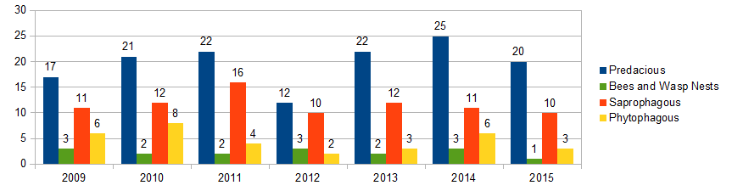
Figure 10 Larval feeding modes - species each year
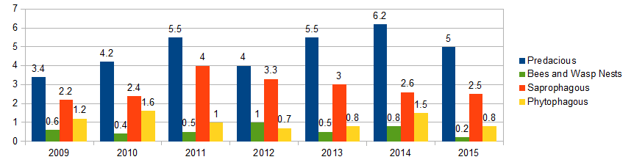
Figure 11 Larval feeding modes - species per visit
Figures 10 and 11 explore the larval feeding modes by species diversity rather than overall numbers of individuals. Although there is some variation in the relative ratios of the hymenoptera associated larvae and the phytophagous larvae, the absolute numbers are very low and may not be significant.
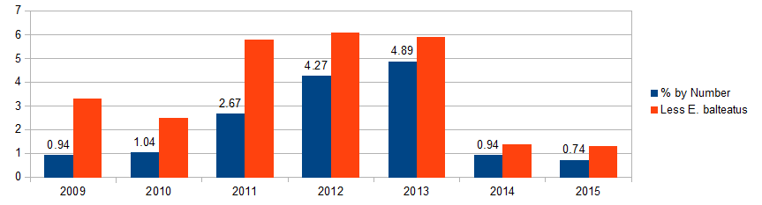
Figure 12 Dead wood/sap run larvae - %age of total abundance of hoverflies each year
Figure 12 shows the variation in the proportion of dead-wood associated species (Xylotini, Volucella inflata and Ferdinandea cuprea). If dead wood and sap runs are not continuously available (after clear felling and stump removal) then these species tend to disappear from the woodland fauna. This does show a large variation in the proportion of species during the survey period. To remove the effect of large influxes of Episyrphus balteatus on the data, the ratios are shown with and without this species. This still shows the variation in the proportion of dead wood species, with 2014 and 2015 showing low numbers. It is not clear why this should be. Further recording is needed to determine if this is just caused by natural variation or a real change in the habitat.
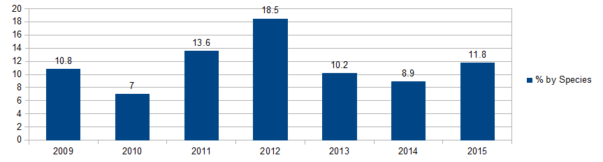
Figure 13 Dead wood/sap run larvae - %age of total species each year
Figure 13 shows the variation in the proportion of dead wood species by species diversity rather than total numbers of individuals. The diversity does not show the same decline in 2014 and 2015 as the total number of individuals did.
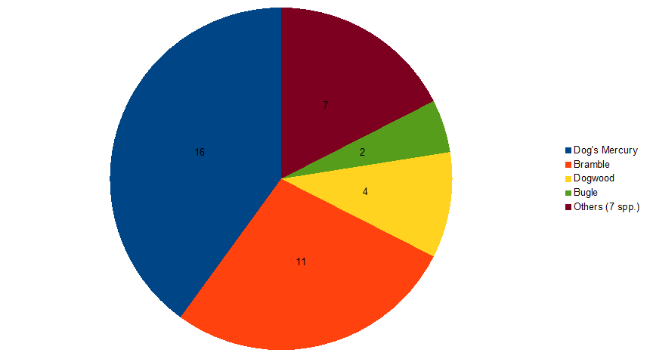
Figure 14 Most commonly visited spring flower species

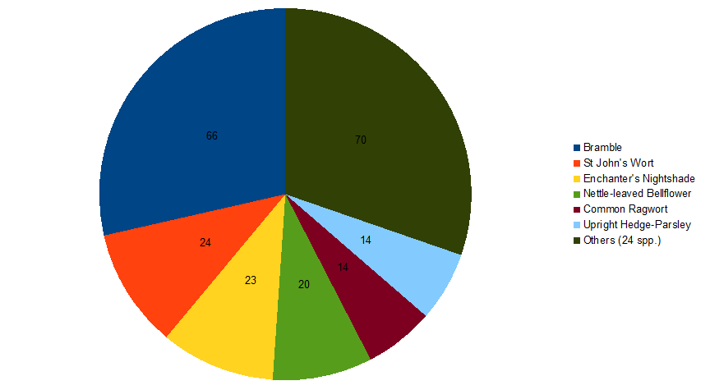
Figure 15 Most commonly visited summer flower species
During the surveys, flower visits by hoverflies were noted (figs 14 & 15). One flower visit was recorded if at least one hoverfly was seen at a flower in a compartment on a survey visit. No attempt was made to record the number of hoverflies visiting each flower as this would have been too time-consuming and repeat visits could affect the counts.
It should be noted that a flower visit was counted if the hoverfly landed on or hovered very close to a flower, not when actual nectar drinking was seen. This means that the data does not necessarily reflect the nectar preferences of the hoverflies. In particular, the high proportion of Dog's Mercury (wind pollinated species) visits in the spring data may be just exploration by the hoverflies (mainly Bachini), possibly searching for suitable oviposition sites.
The most noticeable feature of the data is that relatively few flower visits were recorded. This may be due to recorders neglecting to note flower visits in the effort to count total numbers.

Conclusions

Trends in relation to reserve management
The initial data analysis shows no clear trends in relation to reserve management. Further analysis is required to see if there is a direct relationship between management regime and species assemblage.

Strengths/weaknesses of approach
The method is practical if we are able to recruit 2 teams of 2/3 people for each survey visit. This allows:
- 1 person to identify hoverflies in field (experienced person);
- 1 person to record on fieldsheets;
- Others to observe, sweep and help in identifying plants. Beginners can be useful as spotters and catchers
Pre-recording training is essential, ideally the Ball & Morris Wildlife Trust BCN Training Workshop. This has been supplemented with laboratory sessions on the Hoverwatch project days.

6.3 Future data analysis and collection
The initial data analysis has been a useful exercise to assess the methodology and begin data interpretation. The following recommendations for future data analysis are made:

Remove the very common species Episyrphus balteatus from the dataset as this species is affected by irregular eruptions of immigrants;

Statistical analysis of hoverfly populations and flowering spike counts (currently being processed). Use nectar source monitoring data;

Statistical analysis of hoverfly populations and compartment management;

Continue with data collection at Old Sulehay;

Write standardised hoverfly monitoring methodology for WT reserves

References

Ball, S. and Morris, R., 2012 The Hoverfly Recording Scheme-putting Diptera on the map
Rotheray, G.E., 1993. Colour Guide to Hoverfly Larvae (Diptera, Syrphidae). Dipterists Digest No. 9. Derek Whiteley, Sheffield, England
Stubbs, A.E., 1982. Hoverflies as Primary Woodland Indicators with Reference to Wharncliffe Woods. Sorby Record, No. 20, 62-67

Acknowledgements
Henry Stanier, Great Fen Ecology & Recording Officer,
Wildlife Trust for Beds, Cambs and Northants
Roger Morris and Stuart Ball, Hoverfly Recording Scheme
Regular long-term volunteers:
Peter McMullen
Kev Rowley
Graham Warnes
The many other volunteers who have taken or are currently taking part in the project.

Appendices

Appendix 1 Complete species list and indicator codes

The table shows the species recorded during the survey. The other columns show habitat and larval feeding modes for the species.
Woodland Indicator (Stubbs 1982)
1 – there is some association
2 – there is moderate association
3 – there is strong association.
Larval Feeding
P – predatory larvae
M – mycophagous larvae (feeding in fungi)
Ph – phytophagous larvae feeding in plants
S – saprophagous larvae feeding on rotting plant material, including dung, sap runs and dead wood
Sc – scavenger in hymenoptera nests
Larval Habitat (Rotheray 1993)
A - Arboreal
ADV – Aquatic decaying vegetation
AN – Ants' nests
B - Bulbs
BN – Bees and wasps' nests
D - Dung
GL – Ground layer
H - Herbs
LS – Low shrubs
M – Manure/compost
R - Roots
RH – Rot-holes
S - Soil
SR – Sap-runs
V - Various
WD – Wood decay

