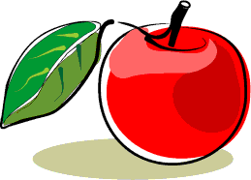
Fruit Varieties

Apples
Early varieties (to pick in August)
Lord Peckover
Lady Hollendale
Red Victoria

Mid varieties West (to pick in September to early October)
St. Everard
Huntingdon Codlin
Wayside
Thoday's Quarrenden
Jolly Miller

Mid varieties East (to pick in mid October)
Chivers Delight
Cockett's Red
Murfitt's Seedling
Morley's Seedling
Barnack Beauty
New Rock Pippin

Late varieties (to pick in late October)
Histon Favourite
Green Harvey
Cottenham Seedling
Lord Burghley
New Rock Pippin

Pears
Conference

Robin
Buerre Bedford

Plums
Merryweather Damson
Cambridge Gage
Willingham Gage
Blue Tit
Laxton’s Goldfinch
Wallis’s Wander (to be planted 2011)

Cherries
Strawberry Heart
Polstead Black
Summer Sun
Merchant

Others
Mulberry Black
Medlar Nottingham
Quince Vranja

There are two or three trees of each variety except the mulberry, medlar and quince. All the apples and some of the plums are Cambridgeshire varieties. The other plums and the pears and cherries are East of England varieties.

